JRAHS 2005 TRIAL HSC – EXTENSION II

Question 1 (15 marks ) |  |  |  | Marks
(a) |  | Find 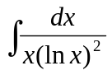 . |  | 2
(b) |  | Find 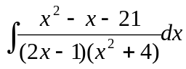 . |  | 4
(c) |  | Evaluate 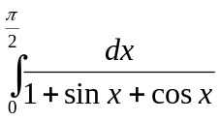 . |  | 4
(d) | (i) | Prove 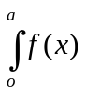dx =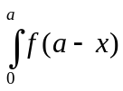dx . |  | 2
 | (ii) | Hence evaluate 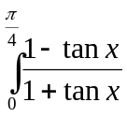 dx . |  | 3
Question 2(15 marks) ( Start a new page )

(a) |  | Express z =  + i in modulus-argument form. |  | 3
 |  | Hence show that z+ 64 z = 0.
(b) |  | On an argand diagram the point P representing the complex number z moves so that 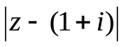= .
 | (i) | Sketch the locus of P . |  | 2
 | (ii) | Find the greatest value of 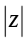. |  | 2
 | (iii) | Shade the region where 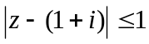 and 0< arg ( z -1)< 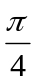 and find the area of this region. |  | 3
(c) |  | If w is one of the complex roots of z= .
 | (i) | Show that w is also a root. |  | 1
 | (ii) | Show that 1 + w+ w= . |  | 1
 | (iii) | Evaluate (-w)(-w)(-w)(-w). |  | 3
Question 3 (15 marks) (Start a new page) |  |  |  | Marks
(a) |  | Given that x + i is a factor of P(x)= x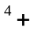 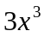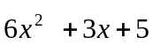, |  | 4
 |  | factorize P(x) over the complex field.
(b) |  | Given that the equation x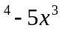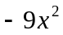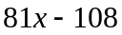= has a root of multiplicity 3, find all the roots of this equation. |  | 3
(c) |  | If α, β, γ are the roots of 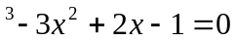,
 |  | find the equation whose roots are
 | (i) | 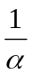, 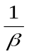, 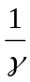 |  | 2
 | (ii) | α, 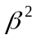, γ . |  | 3
(d) |  | Im(Z)  C(z=7+3i)  A(z=1+i)  Re(Z)  O  B(z)  diagram not to scale
 |  | The points A and C represent the complex numbers  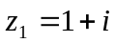 and 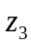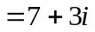.  Find the complex number 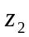 represented by B such that ΔABC is isosceles and right angled at B. |  | 3
Question 4 (15 marks) (Start a new page) |  |  |  | Marks
(a) |  | An ellipse has the equation 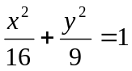.
 | (i) | Sketch the ellipse showing the foci S and S’ and the directrices. |  | 4
 | (ii) | Prove that the tangent at the point P(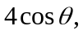 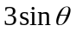) to the ellipse has the equation 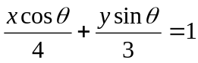 . |  | 3
 | (iii) | The ellipse meets the y-axis at B and B’ . The tangents at B and B’ meet the tangent at P at the points Q and Q’ respectively.  Prove that BQ.B’Q’ = 16 . |  | 3
(b) |  | y  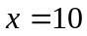  5  y =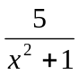  x  10  3  0  diagram not to scale  A circular flange is formed by rotating the region bounded by the curve y = , the x axis and the lines x = 0 and  x = 3, through one complete revolution about the line  x = 10. (All measurements are in centimetres).
 | (i) | Use the method of cylindrical shells to show that the volume V cm of the flange is given by V = 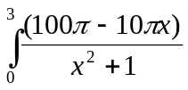 dx . |  | 2
 | (ii) | Find the volume of the flange correct to the nearest cm. |  | 3
Question 5 (15 marks) (Start a new page) |  |  | Marks
(a) |  | y  diagram not to scale  A(1,1)  O  x  B(-1,-1)  In the diagram above, the curve y = 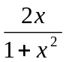 is sketched with turning points A(1,1) and B(-1,-1).
 | (i) | On separate diagrams, draw sketches of :
 |  | (α) y = 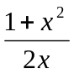 | 2
 |  | (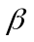) y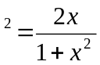 | 2
 |  | () 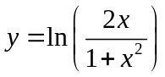. | 2
 | (ii) | Show that the equation 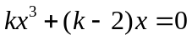 can be written in the form of = 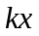 . | 1
 | (iii) | Using a graphical approach based on the curve y = 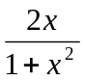 , or otherwise, find the real values of k for which the equation 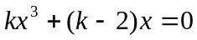 has exactly one real root. | 2

(b) | (i) | A particle of mass m travels with constant speed v in a horizontal circle of radius R, centre C around a track banked at an angle to the horizontal. The acceleration due to gravity is g.  (α) Draw a diagram showing the forces acting on the particle.  () Show that if there is no tendency for the particle to slip sideways then 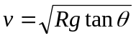. | 1  2
 | (ii) | One particle travels in a horizontal circle of radius 1 metre around the lower half of a track where the angle of banking is 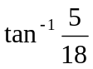. Another particle travels in a horizontal circle of radius 1.2 metres around the upper half of the track where the angle of banking is 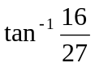. Each particle travels with constant speed so that it has no tendency to slip sideways. The particles are initially observed to be along side each other.  Taking g = 10 m s, find the time that elapses before the particles are next to be alongside each other. | 3
 |  | (Question 6 is continued on the next page)

Question 6 ( 15 marks) (Start a new page) |  |  | Marks
(a) | (i)  (ii) | The line through O perpendicular to the tangent at P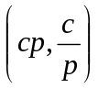 on the rectangular hyperbola xy = cmeets the tangent at N.  Find the coordinates of N.  Show that as p varies, the locus of N is 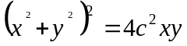 . | 4  3
(b) |  | A drinking glass having the form of a right circular cylinder of radius a and height h, is filled with water. The glass is slowly tilted over, spilling water out of it, until it reaches the position where the water’s surface bisects the base of the glass. Figure 1 shows this position.  diagram not to scale  Figure 1  In Figure 1, AB is a diameter of the circular base with centre C, O is the lowest point on the base, and D is the point where the water’s surface touches the rim of the glass.  Figure 2 shows a cross-section of the tilted glass parallel to its base. The centre of this circular section is C’ and EFG shows the water level. The section cuts the lines CD and OD of Figure 1 in F and H respectively.  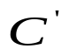  H  E  G  a  F'  Note: EG C’H at F  water  Figure 2  Figure 3 shows the section COD of the tilted glass.  D  C  F  a  h  H  O  Figure 3  Note: FH || CO, CO = a, and OD = h  diagrams not to scale
 | (i) | Use Figure 3 to show that FH =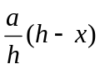, where OH = x. | 1
 | (ii) | Use Figure 2 to show that C’F = 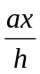 and HC’G= cos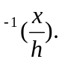 | 2
 | (iii) | Use (ii) to show that the area of the shaded segment EGH is  a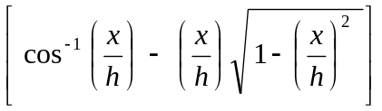. | 2
 | (iv) | Given that 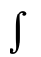cos d= cos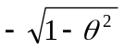,  find the volume of the water in the tilted glass in Figure 1. | 3

Question 7 (15 marks) (Start a new page) |  |  | Marks
(a) |  | A body of unit mass falls under gravity through a resisting medium. The body falls from rest from a height of 50 metres above the ground. The resistance to its motion is 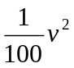 where v metres per second is the velocity of the body when it has fallen a distance x metres. The acceleration due to gravity is g m s.
 | (i) | Show that the equation of the motion of the body is:  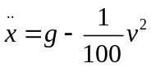. | 1
 | (ii) | Show that the terminal velocity V of the body is given by:  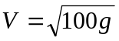 . | 1
 | (iii) | Hence show that v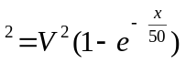. | 4
 | (iv) | Find the distance fallen in metres until the body reaches a velocity equal to 50% that of the terminal velocity. | 2
 | (v) | Find the velocity reached as a percentage of the terminal velocity when the body hits the ground. | 2
(b) |  | In the following figure, AB and CD are two chords of the circles. AB and CD intersect at E. F is a point such that ABF and DCF are right angles.  diagram not to scale  C  A  F  E  B  D
 |  | Copy the diagram onto the your answer sheet.  Prove that FE produced is perpendicular to AD. | 5

Question 8 (15 marks) (Start a new page) |  |  | Marks
(a) | (i) | A light, inextensible string ABC is such that AB = 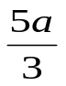 and BC = 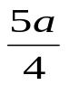. A particle of mass m is attached to the string at C and a mass of 7m is attached at B. The end A is tied to a fixed point and the whole system rotates steadily with uniform angular velocity about the vertical through A in such a way that B and C describe horizontal circles of radii a and 2a respectively. The acceleration due to gravity is g.  2a  B  C  a  A  diagram not to scale  Show that the tension in BC is 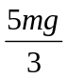. | 3
 | (ii) | Find the tension in AB. | 2
 | (iii) | Find the speeds of B and C. | 4
(b) | (i) | Show that if 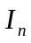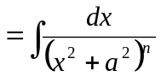, then  = 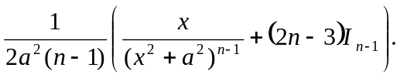 | 4
 | (ii) | Hence evaluate 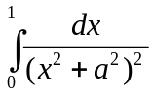 . | 2
 |  | ☺END of Paper ☺

